Which categories will be analyzed and how?

Ian Hussey & Sabrina Norwood

The originally planned analyses focused on 6 categories/modes of behavior. Revisions to the codebook mean that we now have 16 categories along two dimensions. This poses new challenges to how we analyze and report results, both in terms of a) what can be fitted in the model without making it extremely complex to fit and possibly fragile, and b) how to effectively convey results that say something meaningful. Ideas for how to do this are laid out below.

For readers less familiar with the project, a quick recap:
- We will sample 450 articles from 5 journals in each of 6 subfields of psychology across a 15 year time period.
- We code all measures in each article for a) what they measure and b) how they measure it – see table on the next page. We are particularly interested in (non)alignment of what is measured and how, e.g., wanting to measure behavior but using non behavioral measures to do it (e.g., self-reports)
- We model the prevalence and trend of different modes/categories of what is measured and how
- A limited number of specific hypotheses are tested
  - If psychology is the science of behavior, then we should be using behavioral measures of behavior as our DVs with some regularity. If we don’t observe this, then our self-image is out of line with our measurement practices.
  - Estimates of prevalence and trend will be produced for several other things – but what? Help us choose these. Suggestions are presented on the following pages.

 |  | What is being measured (Second dimension)
 |  | Subjective experience  (mental content, often self-perceived) | Mental ability or cognitive process | Behavior  (specific overt behaviors) | Neuro/bio/physiology
How it is  being measured  (First dimension) | Self-report  (and other-report) | Self-report of subjective experience  Self-reported fear of spiders | Self-report of ability  Self-reported intelligence, self-reported empathic perspective taking ability | Self-report of behavior  Self-reported social media use | Self-report of physiology  Self-reported height, weight, amygdala activation, or  heart rate (HBCT)
 | Test  (has correct answers) | Test of subjective experience  Visual search test for synesthesia | Test of cognitive ability  Mental rotation test,  N-back task | Test of behavior  Stimulus equivalence test | Test of physiology  Beighton Score to assess joint hypermobility syndrome
 | Behavioral measure  (non-self-report; frequency, duration or latency of overt behaviors) | Behavioral measure of subjective experience  Implicit racial bias | Behavioral measure of ability  Iowa Gambling Task | Behavioral measure of behavior  Social media use via digital trace data, observational coding | Behavioral measure of physiology  Gait variability to measure the integrity of CNS timing and motor control systems
 | Neuro/bio/physiological measure | Neuro/bio/physiological measure of subjective experience  GSR as a measure of fear | Neuro/bio/physiological measure of ability  Cognitive Control Capacity measured via fMRI | Neuro/bio/physiological measure of behavior  EKG to measure sleep duration,  urinalysis to measure drug consumption | Neuro/bio/physiological measure of neuro/bio/physiology  Structural MRI, Salivatory immunoassays to measure menstrual cycle phase
Table 1. Categories in the table are organized along two dimensions: What is being measured and how it is being measured.

 |  | What is being measured (Second dimension)
 |  | Subjective experience  (mental content, often self-perceived) | Mental ability or cognitive process | Behavior  (specific overt behaviors) | Neuro/bio/physiology
How it is  being measured  (First dimension) | Self-report  (and other-report) | Self-report of subjective experience | Self-report of ability | Self-report of behavior | Self-report of physiology
 | Test  (has correct answers) | Test of subjective experience | Test of cognitive ability | Test of behavior | Test of physiology
 | Behavioral measure  (non-self-report; frequency, duration or latency of overt behaviors) | Behavioral measure of subjective experience | Behavioral measure of ability | Behavioral measure of behavior | Behavioral measure of physiology
 | Neuro/bio/physiological measure | Neuro/bio/physiological measure of subjective experience | Neuro/bio/physiological measure of ability | Neuro/bio/physiological measure of behavior | Neuro/bio/physiological measure of neuro/bio/physiology

Ideas for how to revise the analysis, given there are many more categories now and some may have very low prevalences.

Types of results and plots produced for all the below analyses, but not all have to be produced

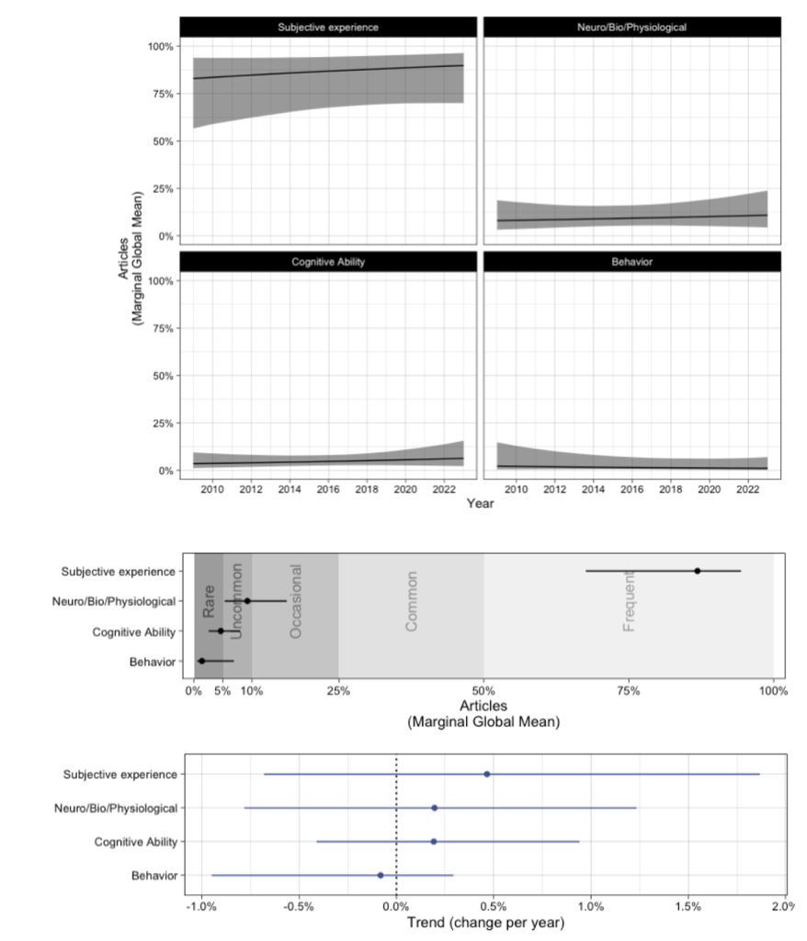

Outstanding questions

- Marginal or conditional estimates?
  - Marginal by field in text
  - Conditional by field and marginal by subfield in supplementaries?
- Parallelisms in Q4 behavior
- RE correlation tables?

Question 1 how

 |  | What is being measured
 |  | Subjective experience | Mental ability or cognitive process | Behavior | Neuro/bio/physiology
How it is being measured | Self-report | Self-report of subjective experience | Self-report of ability | Self-report of behavior | Self-report of physiology
 | Test | Test of subjective experience | Test of cognitive ability | Test of behavior | Test of physiology
 | Behavioral measure | Behavioral measure of subjective experience | Behavioral measure of ability | Behavioral measure of behavior | Behavioral measure of physiology
 | Neuro/bio/physiological measure | N/b/p measure of subjective experience | N/b/p measure of ability | N/b/p measure of behavior | N/b/p measure of n/b/p

1 multivariate model
Scatter, trend, and prevalence plots

Question 2 why

 |  | What is being measured
 |  | Subjective experience | Mental ability or cognitive process | Behavior | Neuro/bio/physiology
How it is being measured | Self-report | Self-report of subjective experience | Self-report of ability | Self-report of behavior | Self-report of physiology
 | Test | Test of subjective experience | Test of cognitive ability | Test of behavior | Test of physiology
 | Behavioral measure | Behavioral measure of subjective experience | Behavioral measure of ability | Behavioral measure of behavior | Behavioral measure of physiology
 | Neuro/bio/physiological measure | N/b/p measure of subjective experience | N/b/p measure of ability | N/b/p measure of behavior | N/b/p measure of n/b/p

1 multivariate model
Scatter, trend, and prevalence plots

Question 3 how and why – common and aligned categories

These are the mainstays of psychology, historically, and we want to assess their prevalence and trend.
 |  | What is being measured
 |  | Subjective experience | Mental ability or cognitive process | Behavior | Neuro/bio/physiology
How it is being measured | Self-report | Self-report of subjective experience | Self-report of ability | Self-report of behavior | Self-report of physiology
 | Test | Test of subjective experience | Test of cognitive ability | Test of behavior | Test of physiology
 | Behavioral measure | Behavioral measure of subjective experience | Behavioral measure of ability | Behavioral measure of behavior | Behavioral measure of physiology
 | Neuro/bio/physiological measure | N/b/p measure of subjective experience | N/b/p measure of ability | N/b/p measure of behavior | N/b/p measure of n/b/p

1 multivariate model
Scatter, trend, and prevalence plots

Question 4: Behavior
 |  | Subjective experience | Behavior  Recent Tech only | Mental ability or cognitive process | Neuro/bio/physiology
How it is being measured | Self-report | Self-report of subjective experience | Self-report of behavior | Self-report of ability | Self-report of physiology
 | Behavioral measure | Behavioral measure of subjective experience | Behavioral measure of behavior  DV only | Behavioral measure of ability | Behavioral measure of physiology
 | Test | Test of subjective experience | Test of behavior | Test of cognitive ability | Test of physiology
 | Neuro/bio/physiological measure | N/b/p measure of subjective experience | N/b/p measure of behavior | N/b/p measure of ability | N/b/p measure of n/b/p

1 univariate model each
Scatter, trend, and prevalence plots each

- Behavioral measure of behavior (already in model 3)
- Self report of behavior
- Behavioral measure of behavior DV only [severe test] don’t need to code non-behav-how?
- What-Behavior - Recent Tech only

Shiny app / supplementaries: individual categories, breakdowns by subfield
- Tables of all of the above
- Plots and tables of the above by subfield
- 1 large multivariate model with all 16 DVs, or 16 univariate models with 1 DV each
- Article’s in text results using different priors (requested by reviewer)

